HANKERTON HISTORY – DID YOU KNOW? #8

As we hear the tractors in the fields and see the harvest being gathered in it is easy to appreciate that farming is still important to Hankerton, but do you know what it was like in the past?

Between the 13th and 16th centuries there were 20 and 25 tenants working on the land mainly owned by Malmesbury Abbey. Hankerton’s open fields were to the west of the village and its common pastures to the north of the church and on the clay south-east of the church.
Villagers would work a strip of common land for grazing and ploughing. This was banked up to aid drainage and increase soil depth and is known as “ridge and furrow”. We are very lucky in Hankerton to have so much ridge and furrow still clearly visible, having survived later ploughing. The information board at Cloatley Meadows shows you exactly where to find it.
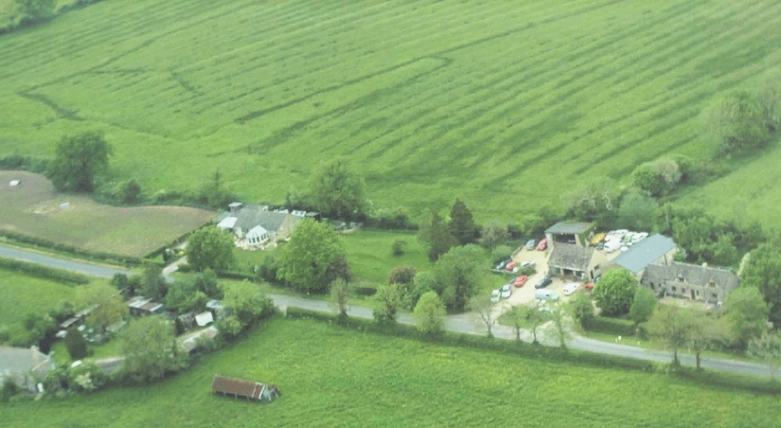
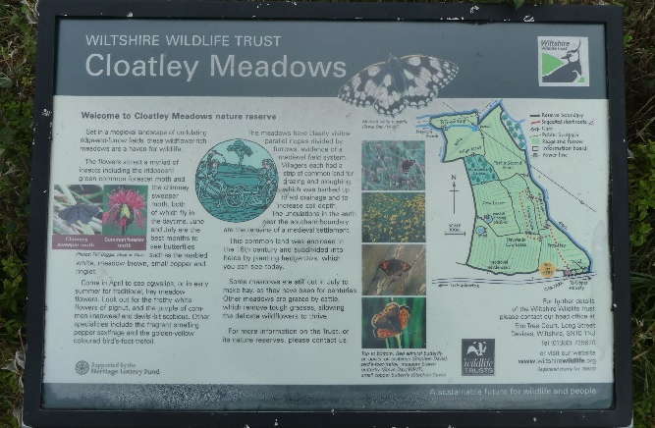

It is often best seen when the sun is low or from the air as shown in the aerial photograph of the field behind Cooper’s Garage.

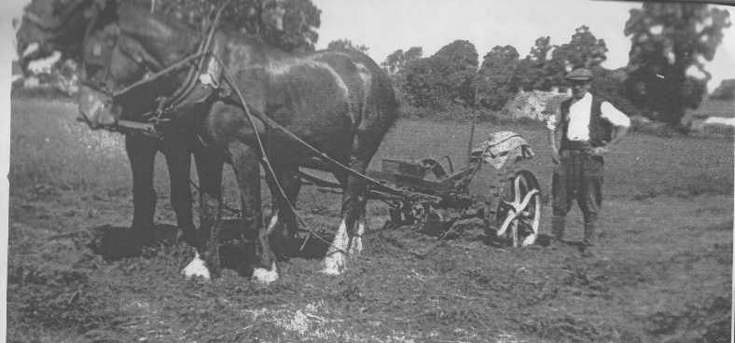
In the 1871 census an amazing number of 13 farmers were listed. These differed in size, one of the largest was Hankerton Field Farm, worked by Richard Lea, which covered 301 acres and employed 7 men, 4 boys and 3 women. This is compared with the 8 acres farmed by James Wait which was probably more of a small holding. There would have been a mix of grassland and arable land but arable farming gradually declined with an increase in the 20th century of dairy farms, beef cattle, sheep and pigs being kept in the parish.
The photograph shows Issac Wood at Brook Farm. It was taken in the 1940s, his magnificent horses show that horsepower was still very important for Hankerton farming in the 20th century. Finds of parts of the ploughs and horse shoes used in the fields have been regularly discovered by our metal detector.

Farming continues as the major land use in the village although the number of active farms is much reduced. As you walk round the village it is interesting to note how many of the farmhouses are now private dwellings and how many former barns have also been converted.

Hankerton History Group
Images : HHG, VM, MJG

