HANKERTON HISTORY – DID YOU KNOW? #6

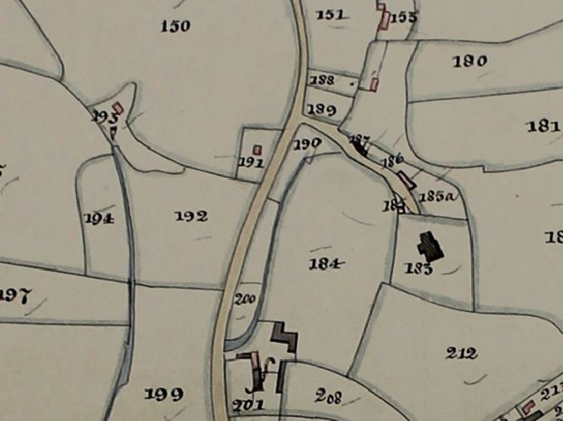
In the past Hankerton was much more self-sufficient than it is today. You may not know that it used to have its own laundry in the cottage now known as “Pear Tree Cottage”. It is one of the oldest cottages in the village and can be clearly seen as plot 191 on the 1841 tithe map. It is described as a Cottage and Garden and was occupied by a Sarah Panter. The numbering system of Hankerton changed several times over the years and the census tended to number houses sort of sequentially. The cottage for a while was known as 28, Hankerton.
Church

It belonged to the Charlton Park estate and was home to the Woodward family from 1851 to 1979. In the early 1900s Mark Woodward, a carpenter lived there, he was commissioned to build the barrel roof over the altar in Hankerton Church. His wife, Mary started the laundry business having been doing laundry since she was 10 years old. Her three daughters joined her in the business.

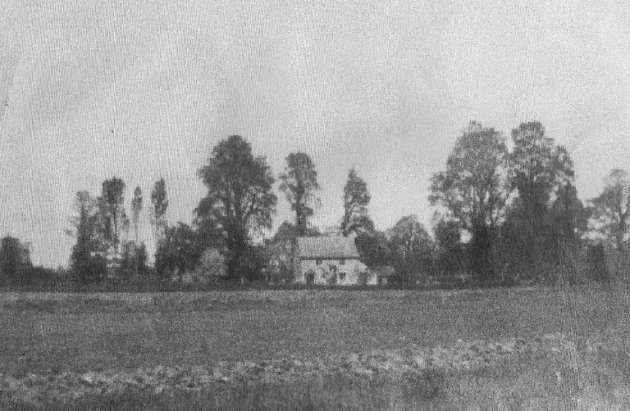
Their customers sent the laundry, delivered by servants, mostly by horse and cart. It was 4d for big linen sheets, 2d for stiff collars and 4d for gentlemen’s evening shirts and riding breeches. They washed and ironed all week. There is a well in the front garden so they would have had an abundant supply of fresh water.
One daughter Eleanor (known as Nellie) stayed in the village and worked the laundry after her mother died. She married Frank Winwood and continued to live in the cottage until her death in 1979. She is still remembered by some villagers.

Although Hankerton has never had a pub there is a tradition that it had what was called a 'Jug and Bottle' where ale was sold. This has long been linked to the area of the Old Laundry and up until the 1970s there was a footpath running up the side of the garden with a stile onto the lane. No trace has ever been found but an educated guess might link it to the building numbered 193 on the tithe map which stood in a small wood. You never know we might still find evidence during further research.
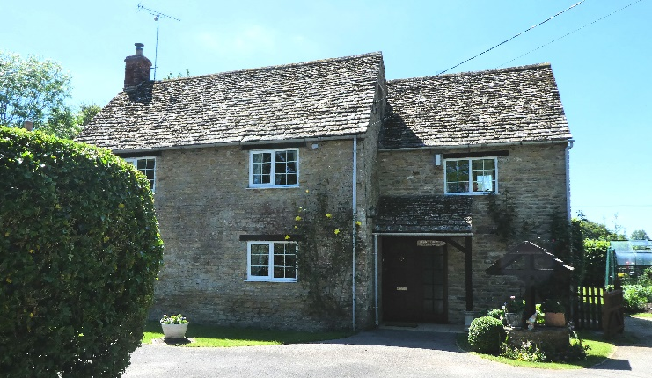

The Earl sold the cottage in 1980 and it has been extended and renovated. It was given the name Pear Tree Cottage because of the huge old Pear Tree in the garden.

Hankerton History Group
Images : HHG, Mike Goodyer

