HANKERTON HISTORY – DID YOU KNOW? #10

We tend to think that village road names and routes are fairly static but our research has revealed some interesting facts about our local lanes.
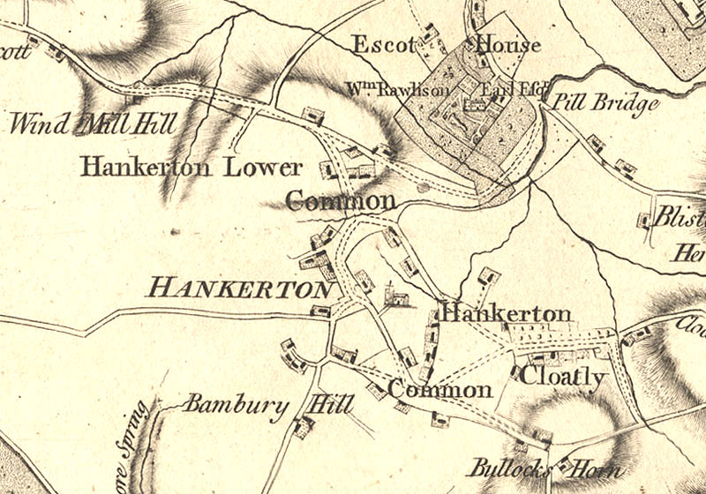
The lane to Murcott was once known as Windmill Hill road. Windmill Hill is clearly shown in this map from the 1770s. We have found out that there was probably a windmill in that area at the end of the 13th century and that the road was still known as Windmill Hill Road in 1809. Investigation and a spot of metal detecting some years ago did not find any remains. You never know – a project for the future.

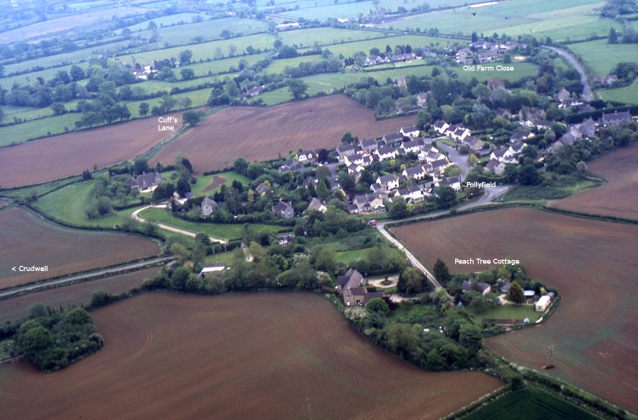

North of the church Cuff's Lane ran between the then Windmill Hill Road and Cloatley Road. The east end of Cuff's Lane was stopped at inclosure in 1809 and the lane fell out of use. It is marked in red on the map and part of it is still used by dog walkers. Just think about the history of that muddy path.

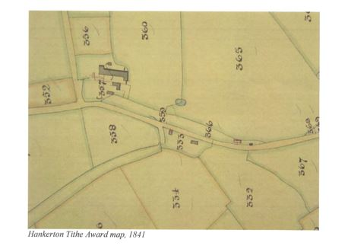
Finally Cloatley Road used to have wide verges and during the 19th century some of the verges were used by squatters to build small dwellings. If you could have a fire in a hearth within 24 hours of starting to build then the building was yours. The cottage east of Cloatley Farm could be an example of one such cottage. The enclosed verge is clearly shown on the Tithe Map of 1841.
The road may also have been used by drovers who could water their livestock at the ponds which still exist.

This is the last “Did You Know” for a while as we do more research and hopefully get to meet up again in person. We are hoping to re-launch the history group at an AGM on 5th April 2022 when we will look at the graffiti in the church. Look out for notices of our meetings.

Hankerton History Group
Images :HHG

