HANKERTON HISTORY – DID YOU KNOW? #3

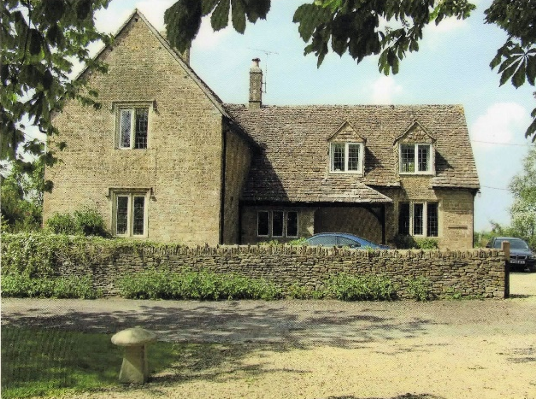
I am sure you have all walked past the Old School House many times, over the years Hankerton History Group has unearthed lots of information about the school which used to be run from here.
It was built between 1850 and 1852 as a National School for boys and girls. Pupil numbers in the 19th century were surprising high, in 1876 we know there were 42 attending school.

Some reports from the Headmistress in the early 20th century still exist and make interesting reading. Attendance was affected by weather both snowfall and wet days but the entry for July 5th, 1907 reads “Due to haymaking, irregular attendance” which gives a good picture of children’s activities.

Gardening also seemed to feature as part of lessons. In February 9th, 1906 there was even an exam on the theory of gardening and in September 11th 1908 a Horticultural Instructor inspected the children's gardens.

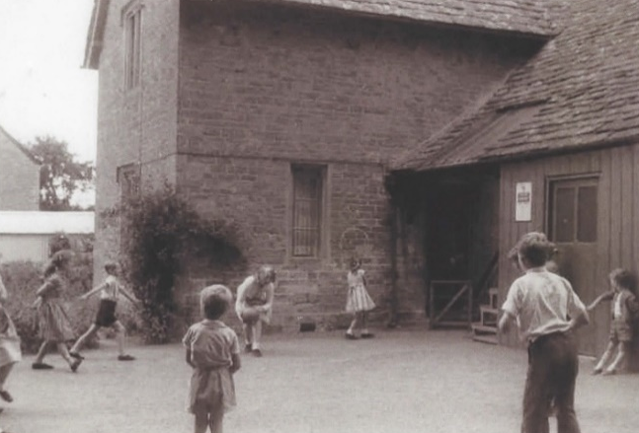
The two pictures date from the mid 20thcentury and show activities in the playground. It is easy to match up with the photograph of the Old School House today.
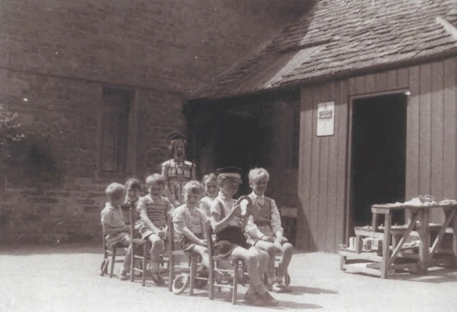
Malmesbury Voices at the Athelstan Museum has a first-hand report of Hankerton School in the 1930s “We had a lovely little school house near the church and on a green. There were about 20 pupils and we had a teacher called Mrs Walters. I was very happy at school. In those days one walked home for lunch, which was, oh, three quarters of a mile from school I would think, and we had lunch and walked back again, and thought nothing of it.
Different classes had the same teacher. Not easy, but she did very well and we used to enter all sorts of competitions, like handwriting”.

By the 1950s the school was struggling, in 1954 two washbasins were requested based on the expectation of mains water supply to the village becoming available. In 1957 the school closed over winter due to an unsafe roof and in March 19th, 1958 it was reported that “Sanitary arrangements were in a deplorable condition and that now mains water was on the premises, there was no need for the present inadequate unhealthy toilets to remain”. There was not much progress, in 1960 there were 11 pupils but the school was on a waiting list for improvements and “would stand a better chance if a sewage system for the village was envisaged”. Again interesting insights into village life.
After many campaigns to save the school, it finally closed in March 1966.

Hankerton History Group. Images P.Wyman, HHG

