FOLLYFIELD

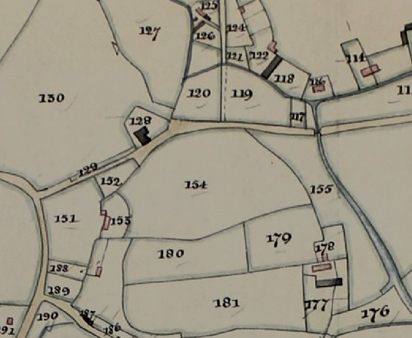
One of the biggest changes in Hankerton during the Queen’s reign has been the building of the houses in Follyfield. This is their story.

Here is the field to be known as Follyfield numbered 154 on the 1841 Tythe Map. You can still follow the curve alongside the path to Chapel Farm. The inventory of the map tells us that the field was owned by the Earl of Suffolk as you might imagine. It was farmed by William Scriven who farmed a number of village fields. These were a mixture of arable and pasture, our field was pasture and was known as Curtis’s. We don’t know who Curtis was.
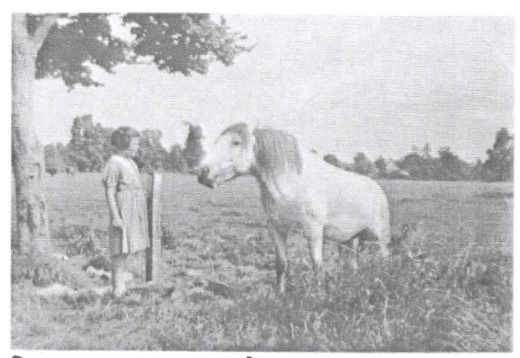
The field seems to have remained the same through into the 20th century. We are lucky enough to have the picture on the left taken from Hillwell looking into Follyfield. The land is still pasture, judging from the girl’s dress this looks like the 1950s.

In September 1959 the Earl of Suffolk sold the land to Frances George Webb and Margaret Ratcliffe Webb, they in turn sold it to Simmons and Son Ltd on 31st January 1966. The construction of Follyfield as we know it then began.

When construction was underway archaeological excavations were carried out by what would become UWE. Medieval building foundations were found in one plot and a Romano British coin with other fragments in another. Both finds are recorded in the Monuments Register. As gardens were dug Medieval pottery known as Minetyware was also found.
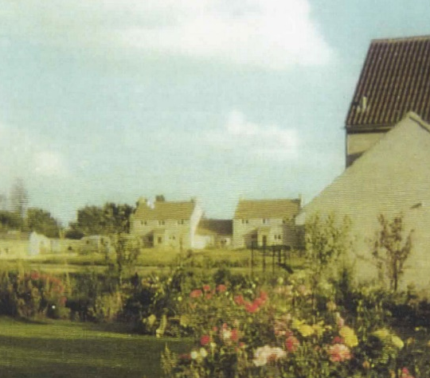
The houses in Follyfield were built one at a time and not in numerical order. Luckily all numbers were allocated before building otherwise Amazon delivery drivers would be even more confused than they are now. Even today some numbers are missing as plots were combined. The picture dates from 1975 and it is amazing how bare everything looks compared with today. Back when the first houses were built there were mature elm trees in the hedgerows around Follyfield but these were felled in 1973 due to Dutch Elm Disease. A reminder that issues such as Ash Dieback are not new.

